Computer Network (OlCE0410)

Lab Manual (2024-25)

Name: Vadgama Harsh D.

ER No.: 92410103123

Class: 4 EC5 Lab Batch: C

**Practical 2: Demonstrate different types of network cables and practically implement the cross-wired cable and straight through cable.**

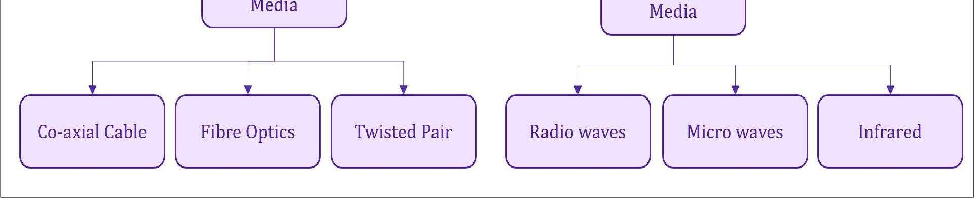

# **Co-axial Cable:-**

Coaxial cables, commonly referred to as coax cables, are widely used in various types of communication systems because of their ability to transmit high-frequency signals with minimal interference. Here’s an overview of their uses and types:

**Usage of Coaxial Cables:**

**Television Signal Transmission:**

* Used to connect TVs, cable boxes, and satellite receivers to the antenna or service provider's equipment.
* They can carry both analogue and digital signals, including video and audio.

**Internet Connectivity:**

* Many broadband internet connections, especially cable internet, use coaxial cables to connect the modem to the service provider's infrastructure.

**Security Systems:**

* Used to connect security cameras to recording devices (like DVRs) and other monitoring systems.

**Audio/Visual Equipment:**

* Coaxial cables are used in the connection of audio and video equipment for high-quality signal transfer.

**Data Transmission in Networks:**

* Coax cables are used in older networking systems (such as Ethernet 10Base2) and can still be seen in some legacy systems.

**Military & Aerospace:**

* Their resistance to electromagnetic interference makes them suitable for military and aerospace applications, where signal integrity is critical.

**RF Applications:**

* They are also used in radio frequency (RF) applications, including wireless communication, antennas, and test equipment.

**Types of Coaxial Cables:**

**RG-6 (Recommended for Cable TV & Internet):**

* **Use:** Commonly used in home television setups and for broadband internet connections.
* **Construction:** Typically has a copper centre conductor, foam insulation, and a braided or solid metal shield.
* **Bandwidth:** Handles high-frequency signals well, often used for longer cable runs.

**RG-59 (Older TV Systems and Low-frequency Use):**

* **Use:** Used in older TV systems, CCTV security camera systems, and short-distance connections.
* **Construction:** Similar to RG-6 but with a thinner centre conductor and less shielding.
* **Bandwidth:** Not suitable for long-distance or high-bandwidth signals.

**RG-11 (For Long Distance or High Power):**

* **Use:** Ideal for long-distance runs of cable, such as for satellite dishes or cable television setups requiring longer cable lengths.
* **Construction:** Larger diameter compared to RG-6 and RG-59.
* **Bandwidth:** Handles higher frequencies and longer distances better than RG-6.

**RG-58 (For Networking and RF Applications):**

* **Use:** Primarily used in older Ethernet networking setups (10Base2) and RF applications.
* **Construction:** Thin with a solid core, often used for shorter runs in networks or radio equipment.

**Quad Shield Coaxial Cable:**

* **Use:** Enhanced shielding for environments with high interference, like in commercial or industrial setups.
* **Construction:** Four layers of shielding (two metal braids and two layers of foil).
* **Benefit:** Provides extra protection against electromagnetic interference (EMI) or radio-frequency interference (RFI).

**LMR (Low Loss Coaxial Cable):**

* **Use:** Common in professional-grade communications, like antenna connections, and for high-frequency signal transmission.
* **Construction:** Low loss dielectric, offering better signal quality over long distances.

**Plenum Rated Coaxial Cable:**

* **Use:** Designed for use in air ducts or plenum spaces of buildings, where fire resistance is required.
* **Construction:** Made with special fire-retardant materials.
* Key Features of Coaxial Cables:
* **Shielding:** Coax cables are shielded to protect the signal from interference (EMI or RFI).
* **Impedance:** Most coaxial cables have a characteristic impedance of 75 ohms (for TV and video) or 50 ohms (for networking and RF).
* **Flexibility:** Some coaxial cables are designed to be more flexible for easier installation in tight spaces, while others are more rigid for long-distance signal transmission.

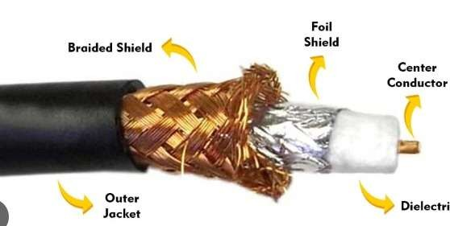

**Fiber Optic Cable:-**

Fiber optic cables are a key technology for transmitting data over long distances at very high speeds, with minimal signal loss. They use light pulses instead of electrical signals to carry data, which allows them to support much higher bandwidth and offer better performance than traditional copper cables.

**Usage of Fiber Optic Cables:**

**Internet and Data Communication:**

* Fiber optic cables are widely used for high-speed internet connections, especially for backhaul infrastructure connecting internet service providers (ISPs) and data centers.
* They also serve in business and residential networks, offering high-speed broadband services.

**Telecommunications:**

* Fiber optics are integral to the backbone of global telecommunications networks, used for voice, video, and data transfer.
* They support long-distance telephone lines, as well as mobile phone networks.

**Cable Television:**

* Many cable television providers use fiber optic cables to deliver high-quality video signals to consumers, especially for services like on-demand TV and streaming.

**Medical Applications:**

* Fiber optics are used in medical instruments such as endoscopes for non-invasive procedures that involve light transmission to capture images of internal organs.
* They are also used in sensors for monitoring bodily functions.

**Military and Aerospace:**

* Fiber optic cables are used for secure communication systems, as they are more difficult to tap into than traditional copper cables.
* They are also used in systems where electromagnetic interference (EMI) is a concern.

**Industrial and Network Applications:**

* Used in industrial settings for automation, monitoring, and control systems.
* In data centers, fiber optics form the backbone of local area networks (LANs) due to their high-speed capabilities.

**Sensors and Sensing Systems:**

* Fiber optics are used in various sensor technologies, including temperature, pressure, and vibration sensors, often in harsh environments.

**Types of Fiber Optic Cables:**

Fiber optic cables are primarily categorized by core type and construction type. Here's a breakdown of the key types:

**1. Single-Mode Fiber (SMF):**

* **Core Size:** Small core diameter, typically 8 to 10 microns.
* **Transmission Type:** Transmits a single mode of light, which allows the signal to travel over long distances without distortion.
* **Use:** Best for long-distance applications such as internet backbone networks, telecommunications, and high-speed data transmission over large areas (up to several kilometers or more).
* **Advantages:** Higher bandwidth, less signal attenuation, suitable for high-speed and long-distance data transmission.
* **Example:** Used in undersea cables, large data centers, and cross-country network links.

**2. Multi-Mode Fiber (MMF):**

* **Core Size:** Larger core diameter, typically 50 to 100 microns.
* **Transmission Type:** Transmits multiple modes of light, which can cause some signal dispersion over longer distances.
* **Use:** Ideal for shorter-distance applications (within buildings or campuses), such as local area networks (LANs), data canter’s, and internal communications in buildings.
* **Advantages:** Easier to work with and install, more cost-effective for shorter distances.
* **Disadvantages:** Limited distance compared to single-mode fibre; performance degrades over longer distances due to signal dispersion.

**3. Plastic Optical Fiber (POF):**

* **Core Size:** Larger core than glass fibers, typically around 1 mm.
* **Transmission Type:** Transmits light using plastic instead of glass. While not as efficient as glass fibers, they are still used for short-distance, low-cost applications.
* **Use:** Often used for internal or consumer applications (e.g., within homes for high-speed networking), automotive applications, and industrial systems that require lower cost.
* **Advantages:** Flexible, easy to install, lower cost compared to glass fiber.
* **Disadvantages:** Limited data rate and distance compared to glass fibers.

4. **Armoured Fiber Optic Cable:**

* **Use:** Designed for installation in environments where the fiber cable may be exposed to physical damage, such as in outdoor environments, industrial sites, or undersea cable installations.
* **Construction:** Contains an additional layer of steel or other metal armour surrounding the cable to protect the fibers inside from impact or crushing.

**5. Loose Tube Fiber Optic Cable:**

* **Use:** Primarily used for outdoor and long-distance applications, such as in telephone networks and internet backhaul.
* **Construction:** The fibers are placed inside small, flexible tubes (loose tubes) that are further surrounded by protective materials to shield against environmental factors like moisture, temperature fluctuations, and physical stresses.

**6. Tight-Buffered Fiber Optic Cable:**

* **Use:** Used in indoor environments, often in data centers, LANs, and within buildings.
* **Construction:** The fiber is directly coated with a protective buffer, making it easier to handle and install without additional protective tubing.
* **Advantages:** Easier to manage, suitable for short-distance installations inside buildings.

**7. Ribbon Fiber Optic Cable:**

* **Use:** Used in high-density applications, like large-scale data centers.
* **Construction:** Contains multiple fibers organized into flat ribbons, allowing for high fiber count cables to be managed and deployed efficiently.
* **Advantages:** Allows for a high number of fibers to be packed into a smaller space, useful in data center networks where space and fiber count are crucial.
* Key Features of Fiber Optic Cables:
* **Bandwidth:** Fiber optics offer significantly higher bandwidth compared to copper cables, enabling faster data transmission.
* **Signal Distance:** The loss of signal is much lower in fiber optics, allowing for longer transmission distances without the need for signal boosters.
* **Immunity to EMI:** Fiber optic cables are not affected by electromagnetic interference (EMI) or radio-frequency interference (RFI), unlike copper cables.
* **Durability:** They are more resistant to environmental factors such as extreme temperatures and moisture, especially when armoured or used in loose tube designs.

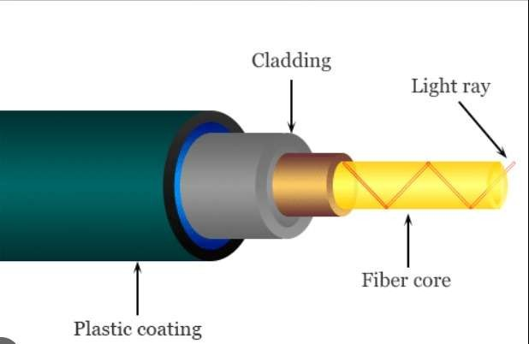

**Twisted Pair Cable:-**

Twisted pair cables are one of the most common types of cabling used in networking and telecommunication systems. They are simple to install and can transmit data over moderate distances. The design consists of pairs of copper wires twisted together, which helps reduce interference from external sources.

**Usage of Twisted Pair Cables:**

**Networking (Ethernet):**

* The most common use for twisted pair cables is in Ethernet networks, where they connect computers, routers, and other devices within local area networks (LANs).
* They can be used for both wired and wireless network backhaul, depending on the type of twisted pair cable used.

**Telecommunications:**

* Twisted pair cables are used in traditional telephone systems to transmit voice data between phones and central offices.
* They are also used in digital subscriber lines (DSL) for internet connectivity, especially in older infrastructure.

**Audio and Video Systems:**

* In some audio-visual setups, twisted pair cables can be used to carry audio and video signals, particularly when shielded versions are used to reduce interference.

**Security Systems:**

* Twisted pair cables are frequently used in CCTV systems and other security monitoring devices for transmitting data signals over short to medium distances.

**Industrial and Control Systems:**

* Many industrial automation systems use twisted pair cables to connect control systems, sensors, and machinery, where high-speed data transmission is required over limited distances.

**Types of Twisted Pair Cables:**

Twisted pair cables come in different categories based on their construction, shielding, and the purpose they are designed for. The two main types are Unshielded Twisted Pair (UTP) and Shielded Twisted Pair (STP).

**1. Unshielded Twisted Pair (UTP):**

* **Construction:** UTP cables consist of pairs of wires twisted together without any additional shielding around the wires. This makes them less resistant to electromagnetic interference (EMI) compared to shielded cables.
* **Use:** Commonly used in standard Ethernet networking (e.g., Cat5e, Cat6), telephone lines, and most LAN applications.
* **Advantages:** More affordable and easier to install than shielded cables, flexible, and lightweight.
* **Disadvantages:** More susceptible to interference from nearby electrical devices or other cables.

**2. Shielded Twisted Pair (STP):**

* **Construction:** STP cables have the same twisted pair structure as UTP, but each pair of wires is shielded (often with a metal foil or braid) to protect the signals from external interference. Some STP cables may have an overall shield around all the pairs as well.
* **Use:** Often used in environments with high levels of electrical interference, such as industrial settings or areas with heavy machinery or high-voltage equipment.
* **Advantages:** Better resistance to EMI and RFI, making them more suitable for high-frequency or long-distance applications.
* **Disadvantages:** More expensive and bulkier than UTP cables, requires grounding to be effective.

**3. Foiled Twisted Pair (FTP):**

* **Construction:** FTP cables are similar to STP cables but only have an overall foil shield surrounding all the twisted pairs, not individual shielding for each pair.
* **Use:** Sometimes used in Ethernet networks where moderate shielding is needed, but it’s less common than fully shielded STP.
* **Advantages:** Provides protection from external interference while being lighter and more cost-effective than STP.
* **Disadvantages:** Less effective at minimizing interference compared to STP.

**Category Types of Twisted Pair Cables:**

* The category of twisted pair cable refers to its performance specifications and is a key indicator of its speed, bandwidth, and suitability for different tasks.

**Common categories include:**

**1. Cat5e (Category 5 enhanced):**

* **Speed:** Up to 1 Gbps (Gigabit Ethernet)
* **Use:** Commonly used for basic Ethernet networking (100BASE-T, 1000BASE-T) and voice transmission.
* **Bandwidth:** 100 MHz
* **Distance:** Up to 100 meters (328 feet)
* **Construction:** UTP or STP
* **Advantages:** Affordable and sufficient for most home and small office networking needs.

**2. Cat6 (Category 6):**

* **Speed:** Up to 10 Gbps (for short distances)
* **Use:** Ideal for high-speed networking, including Gigabit Ethernet (1000BASE-T) and 10 Gigabit Ethernet (10GBASE-T).
* **Bandwidth:** 250 MHz
* **Distance:** Up to 55 meters (180 feet) for 10 Gbps; up to 100 meters (328 feet) for lower speeds
* **Construction:** UTP or STP
* **Advantages:** Provides higher speed and bandwidth than Cat5e, commonly used in modern office environments and data centers.

**3. Cat6a (Category 6 augmented):**

* **Speed:** Up to 10 Gbps
* **Use:** Used for 10 Gigabit Ethernet networking in environments with high data transfer needs.
* **Bandwidth:** 500 MHz
* **Distance:** Up to 100 meters (328 feet) for 10 Gbps
* **Construction:** Typically STP to ensure better protection from interference.
* **Advantages:** Supports higher speeds and better performance over longer distances than Cat6.

**4. Cat7 (Category 7):**

* **Speed:** Up to 10 Gbps
* **Use:** Often used in high-speed networking, data centers, and other environments where large data transfers are common.
* **Bandwidth:** 600 MHz
* **Distance:** Up to 100 meters (328 feet)
* **Construction:** Always STP, with individual shielding for each pair and an overall shield.
* **Advantages:** Provides the highest level of shielding and protection from interference.
* **Disadvantages:** More expensive and harder to work with due to its thicker construction.

**5. Cat8 (Category 8):**

* **Speed:** Up to 25 Gbps (for short distances)
* **Use:** Primarily used in data centers for high-speed connections between network equipment.
* **Bandwidth:** 2000 MHz
* **Distance:** Up to 30 meters (98 feet) for 25 Gbps; suitable for server rooms and data centers.
* **Construction:** Always STP.
* **Advantages:** Extremely high speed and bandwidth, ideal for data-heavy applications.
* **Disadvantages:** Shorter distance than lower category cables, typically used only in very specific applications.

